WHAT TO DO – COVID19 PREVENTION

Protect yourself and others

To prevent the spread of COVID19, practise good hygiene and social distancing.
You should also follow the advice for travellers and advice for public gatherings and visits to vulnerable groups.

Current advice from Queensland Health:

- Clean hands with soap and water, or alcohol-based hand rubs.
- Cover your nose and mouth with a tissue or flexed elbow when coughing or sneezing.
- Avoid contact with anyone who has symptoms such as fever, a cough, sore throat, fatigue, and shortness of breath.
- Stay home if you are unwell.
- Try to stay at least 1.5 metres away from people coughing or sneezing.

Good hygiene

Everyone must practise good hygiene to protect against infection and prevent the virus spreading.

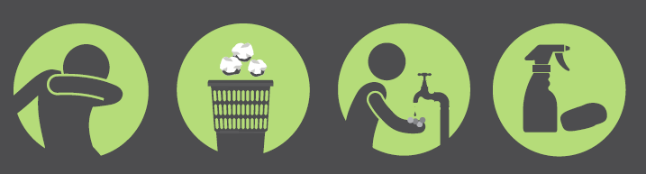

Good hygiene includes:

- Clean your hands with soap and water for 20 seconds, or an alcohol-based hand rub.
- Cover your nose and mouth when coughing and sneezing with tissue or a flexed elbow
- Avoid close contact with anyone with cold or flu-like symptoms.
- Practice cough etiquette (keep away from other people, cover coughs and sneezes with disposable tissues or clothing, and clean your hands.
- Practicing social distancing

WHAT TO DO – COVID19 RESPONSE

If you become unwell

If you have a fever, cough, difficulty breathing, seek medical attention early.

Stay home if you feel unwell. If you have a fever, cough and difficulty breathing, seek medical attention and call in advance. Follow the directions of your local health authority.

If you or someone you have had contact with is diagnosed with COVID19

if you fall under one of the categories below then you are required to socially isolate yourself for 14 days:

- diagnosed with COVID-19
- in close contact with someone that has been diagnosed with COVID-19 in the last 14 days
- have travelling internationally in the last 14 days

Socially isolating means you:
- do not go to public places such as work, school, shopping centres, childcare or university
- ask someone to get food and other necessities for you and leave them at your front door
- do not let visitors in — only people who usually live with you should be in your home

You do not need to wear a mask in your home. If you need to go out to seek medical attention, wear a surgical mask (if you have one) to protect others.
You should stay in touch by phone and on-line with your family and friends.

Please see attachment in pack Home Isolation Information Sheet for further information

Current advise

Helplines

At the current stage of pandemic, our emergency lines & health government lines have been receiving an overwhelming amount response to COVID 19. If you do have concerns, please try and seek information from Australian Government Department of Health website - Australia Government Health Alerts. If your queries are not resolved with the online information, a call would then be appropriate.

Contacts

Coronavirus Health Information Line – 1800 020 080
Non-urgent Medical Help – 13 HEALTH (13 43 25 84)
Emergency – 000
Mental health access line - 1300 MH CALL (1300 642 255)

Useful links

Australian Government Department of Health
Queensland Government COVID19 Information
World Health Organisation
Centers for Disease Control and Infection
Smart Traveller - COVID 19

