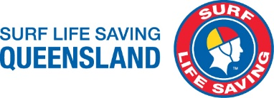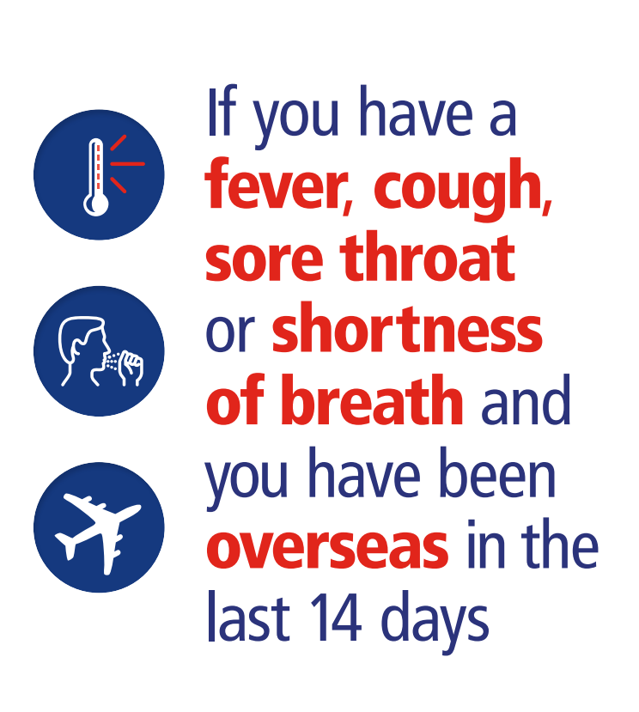

**PLEASE DO NOT COME INSIDE AN SEEK**

**PROFESSIONAL HEALTH ADVICE**

**We are sorry for any Inconvenience**